Contract Specifications of Gold Mini

Symbol – GOLDM

Trading unit (lot size) – 100 grams

Quotation/Base Value – 10 grams

Maximum Order Size – 10kg

Tick Size – Re. 1 per 10 grams

Initial Margin – Minimum 6% or based on SPAN, whichever is higher

Extreme loss margin - Minimum 1%

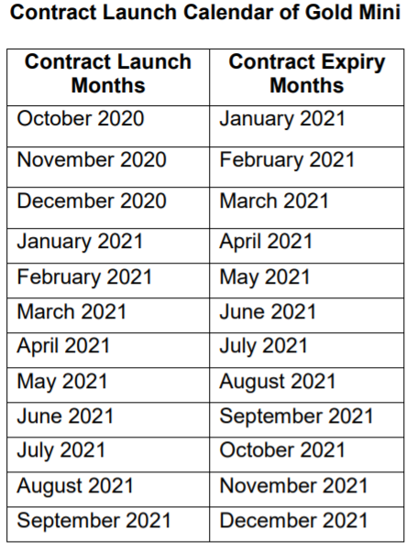

Returns

Near Month Futures

|  |  |  |  |
| --- | --- | --- | --- |
| Buy and Hold |  | Daily |  |
| Mean | 0.048017 | Mean | 0.000365 |
| Max | 0.087398 | Max | 0.017292 |
| Min | 0.008614 | Min | -0.03103 |
| SD | 0.017628 | SD | 0.007158 |
| Sharpe Ratio | -0.92369 | Sharpe Ratio | -8.9318 |

Far Month Futures

|  |  |  |  |
| --- | --- | --- | --- |
| Buy and Hold |  | Daily |  |
| Mean | 0.038261 | Mean | 0.000284 |
| Max | 0.080443 | Max | 0.016904 |
| Min | -0.0017 | Min | -0.03154 |
| SD | 0.018388 | SD | 0.007026 |
| Sharpe Ratio | -1.41605 | Sharpe Ratio | -9.11086 |

Convenience Yield/ Cost of Carry

The storage costs of gold are relatively low. The convenience yield of gold depends on i) demand for jewelry, ii) demand for bullion as a safe haven store of value, or iii) demand for bullion to meet settlement obligations under expiring gold contracts, all of which affect the physical market. Therefore, whenever the cost of carry of gold becomes negative, it indicates a strain in the physical market and is a strong bullish signal.

Liquidity

| **Instrument** | **Year** | **Traded Contract (Lots)** | **Quantity (000's)** | **Total Value (Lacs)** |
| --- | --- | --- | --- | --- |
| FUTCOM | 2021 | 5774929 | 577492.900 GRMS | 27348650.78 |

From the data available on mcx, we can clearly see the number of gold mini contracts traded is extremely high, hence giving gold mini futures high liquidity.

Other Strategy

We have used technical analysis to analyse the graphs for both near and far month futures. Using candlestick graphs, we can identify simple candlestick patterns to book a return of 8.83% on near month futures and 12.32% on far month futures.

Near Month Futures

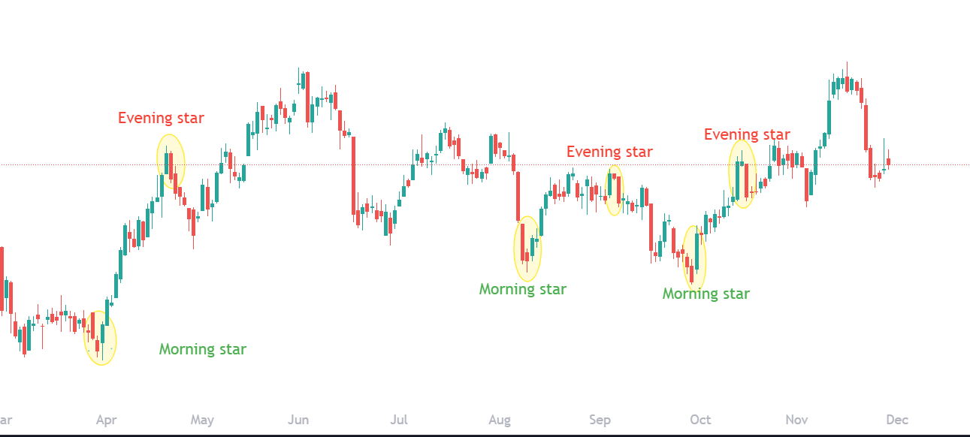

Far Month Futures

